AZURE LANDING ZONE DEPLOYMENT GUIDE

Table of contents Page no

1. Introduction……………………………………………………………………………………………………………….3

2. Architecture Diagram…………………………………………………………………………………………………3

3. Architectural Understanding………………………………………………………………………………………4

4. Naming Convention of Azure…………………………………………………………………………………….5

5. Azure Tagging Strategy……………………………………………………………………………………………..5

6. Terraform File Structure…………………………………………………………………………………………….6

7. Deployment Steps……………………………………………………………………………………………………..6

8. Post Deployment Validation…………………………………………………………………………………….11

1. Introduction:

The architecture for which we have implemented the landing zone is a 3-tier architecture in we are using Hub and Spoke model. In networking part, we have deployed three VNETs and connected them through VNET-peering. For end user connectivity the traffic flow is bi-directional via Application Gateway, VPN to connect for developers (Cyient internal team) through Azure Bastion/RDP/SSH connection. And we have VPN Gateway to connect to on-premises.

2. Architecture Diagram:

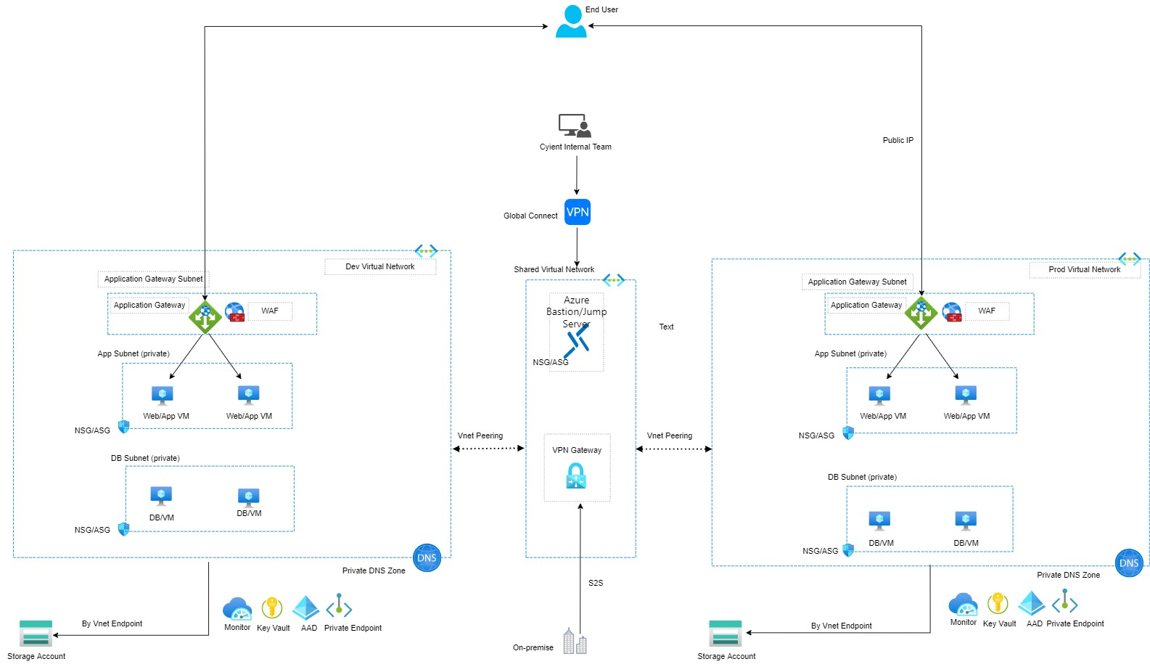

3. Architectural Understanding

Below are the three VNETs deployed

**Cyient_Azure_LandingZone_Automation_workload_vnet**

**Cyient_Azure_LandingZone_Automation_bastion_vnet**

**Cyient_Azure_LandingZone_Automation_test_vnet**

3.1. Cyient_Azure_LandingZone_Automation_workload_vnet

In Workload Vnet we have created 6 subnets in which two of them are public and four of them are private subnets. First two subnets will act as DMZ (Demilitarize zone) they will forward the traffic from front end subnets to backend subnets. In the four backend subnets, two are for the application layer and the other two are for the database.

3.2. Cyient_Azure_LandingZone_Automation_bastion_vnet

It has AzureBastionSubnet where we deploy Azure Bastion Host to connect to virtual machines, this vnet acts as Hub Vnet. As per the security considerations developers to connect virtual machines using bastion and peering will be established to other spoke virtual networks.

3.3. Cyient_Azure_LandingZone_Automation_test_vnet

It will be same as Cyient_Azure_LandingZone_Automation_workload _vnet, it also has 6 subnets created, we are having two of them as public and four of them as private subnets. The first two subnets will act as demilitarized zone, they will forward traffic from front end subnets to backend subnets. In the four backend subnets, two are for the application layer and the other two are for the database.

VNETS PEERING:

Vnet peering will be established as per the architecture which is Hub and Spoke model.

Peering connectivity will be bi-directional as below

Cyient_Azure_LandingZone_Automation_bastion_vnet to Cyient_Azure_LandingZone_Automation_workload_vnet

and from

Cyient_Azure_LandingZone_Automation_bastion_vnet to Cyient_Azure_LandingZone_Automation_test_vnet.

Ensure peering is successfully established with status as “Connected”.

4. Naming Convention of Azure:

An effective naming convention composes resource names from important information about each resource. A good name helps you quickly identify the resource's type, associated workload, deployment environment, and the Azure region hosting it. For example, a public IP resource for a production SharePoint workload in the West US region might be pip-sharepoint-prod-westus-001.

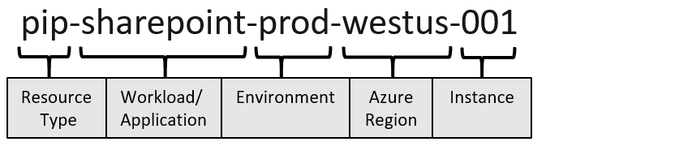

Diagram that shows the components of an Azure resource name.

The choice of a name for any resource in Microsoft Azure is important because:

Consistent naming conventions make resources easier to locate. They can also indicate the role of a resource in a solution.

|  |  |  |
| --- | --- | --- |
| **Resource** | **Syntax** | **Suggested Name** |
| Resource group | organization_Azure_ProjectName_Environment_ServiceName | Cyient_Azure_LandingZone_POC_resource_group_2 |
| Vnet | organization_Azure_ProjectName_Environment_ServiceName | Cyient_Azure_LandingZone_Automation_workload_vnet  Cyient_Azure_LandingZone_Automation_bastion_vnet  Cyient_Azure_LandingZone_Automation_test_vnet |
| Subnet | organization_Azure_ProjectName_Environment_ServiceName | Cyient_Azure_LandingZone_POC_pub1subnet |

5. Azure Tagging Strategy

Currently, we are using given tags while any resource creation in Azure:

1. Organization
2. BusinessUnit
3. Project
4. Name
5. Environment

6. Backup

6. Terraform File Structure:

Terraform file structure for every resource deployed includes the below format

1. Main.tf
2. Variable.tf
3. Output.tf
4. Terraform.tfvars
5. Providers.tf

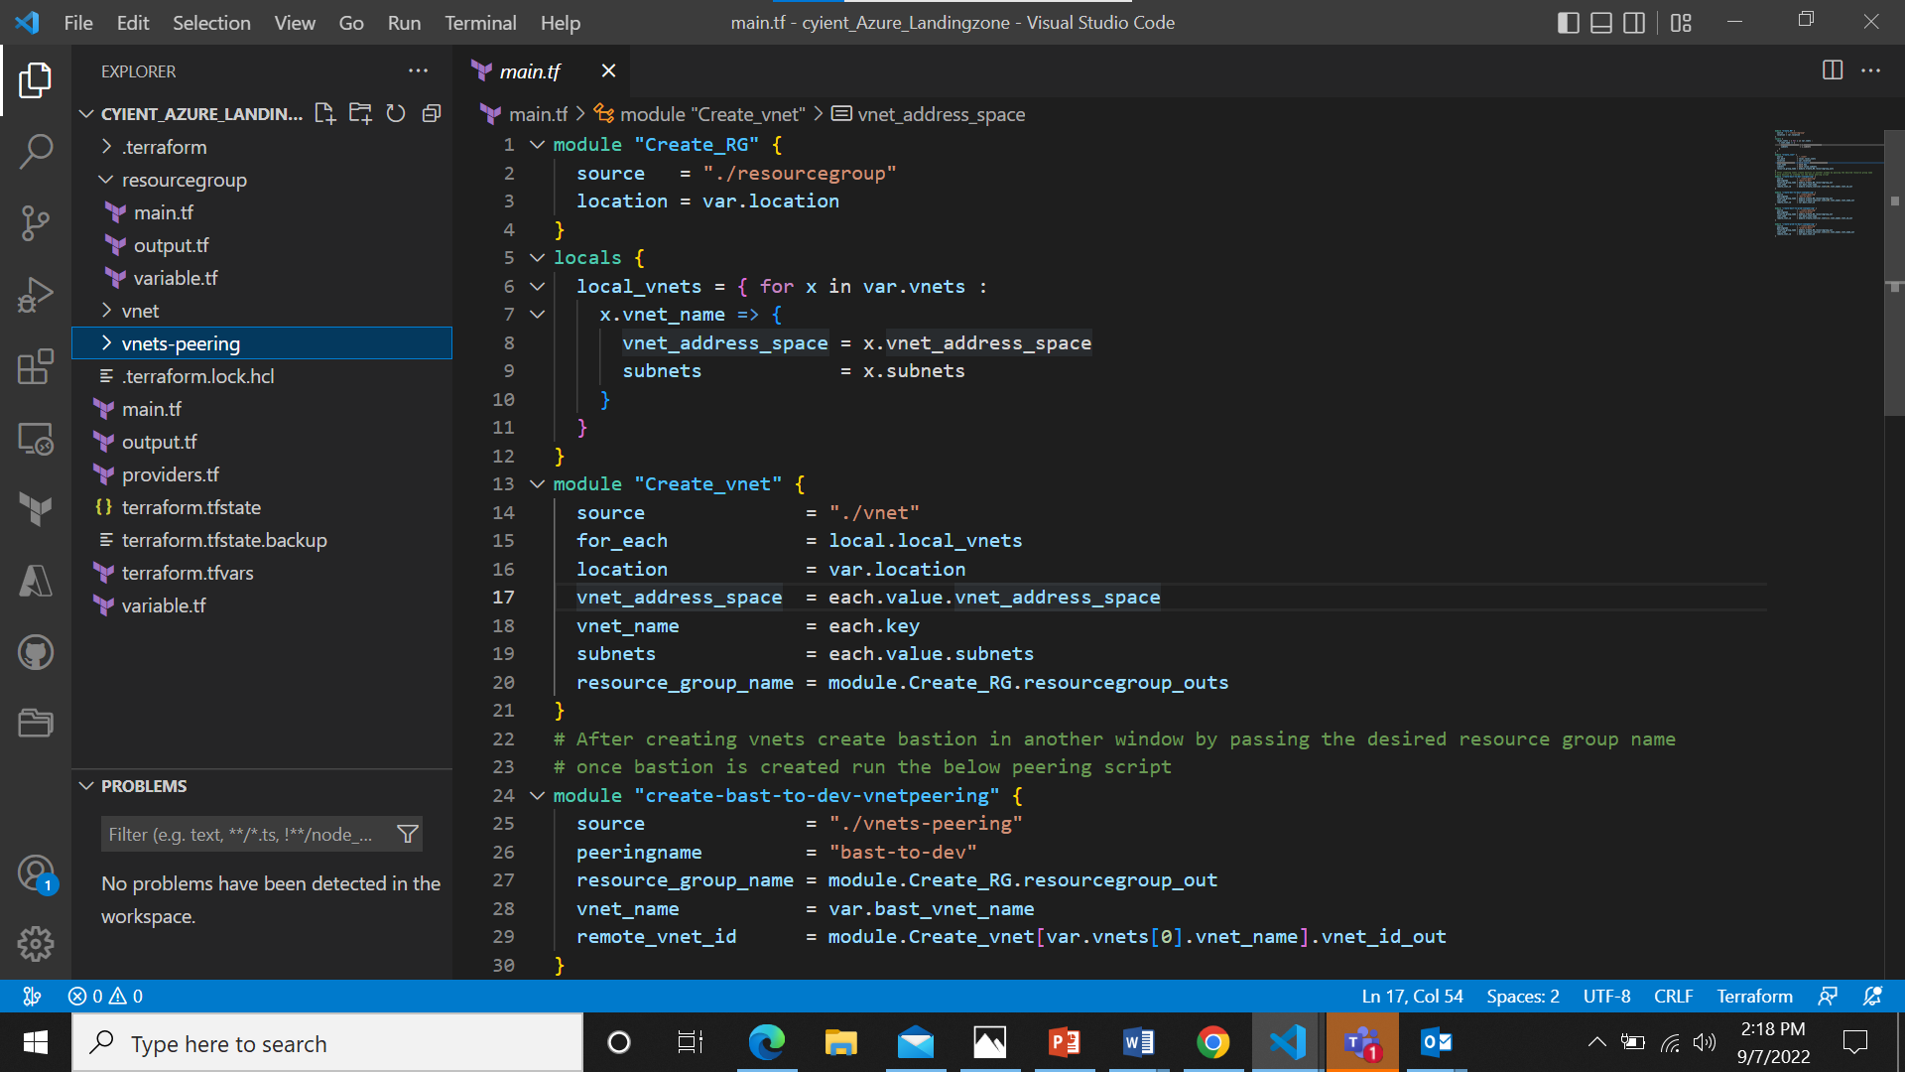##Under Explorer we can find the file structure

7. Deployment Steps:

The script will be in two different files one named as Cyient_Azure_Landingzone and the other as Cyient_Azure_Landingzone_bastion. Cyient_Azure_Landingzone will have various modules to create resources and they need to be called module by module in main.tf and pass the parameters or values for them in terraform.tfvars.

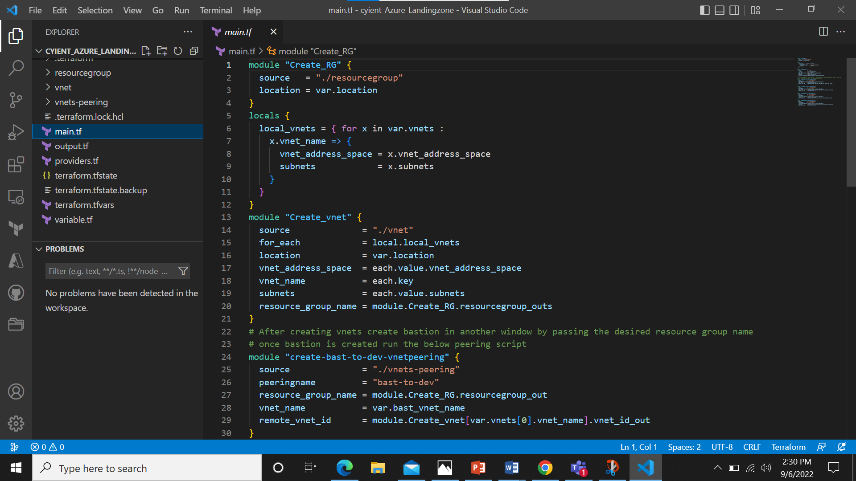

##creation of modules in main.tf

**Step1**: Creation of modules in main.tf

The above picture is a sample of terraform module creation in main.tf .Here we have modules for creation of resource group vnet and implementation of hub and spoke peering by using modules individually to do the peering from Cyient_Azure_Landingzone_bastion to Cyient_Azure_Landingzone_workload_vnet and Cyient_Azure_Landingzone_test_vnet.

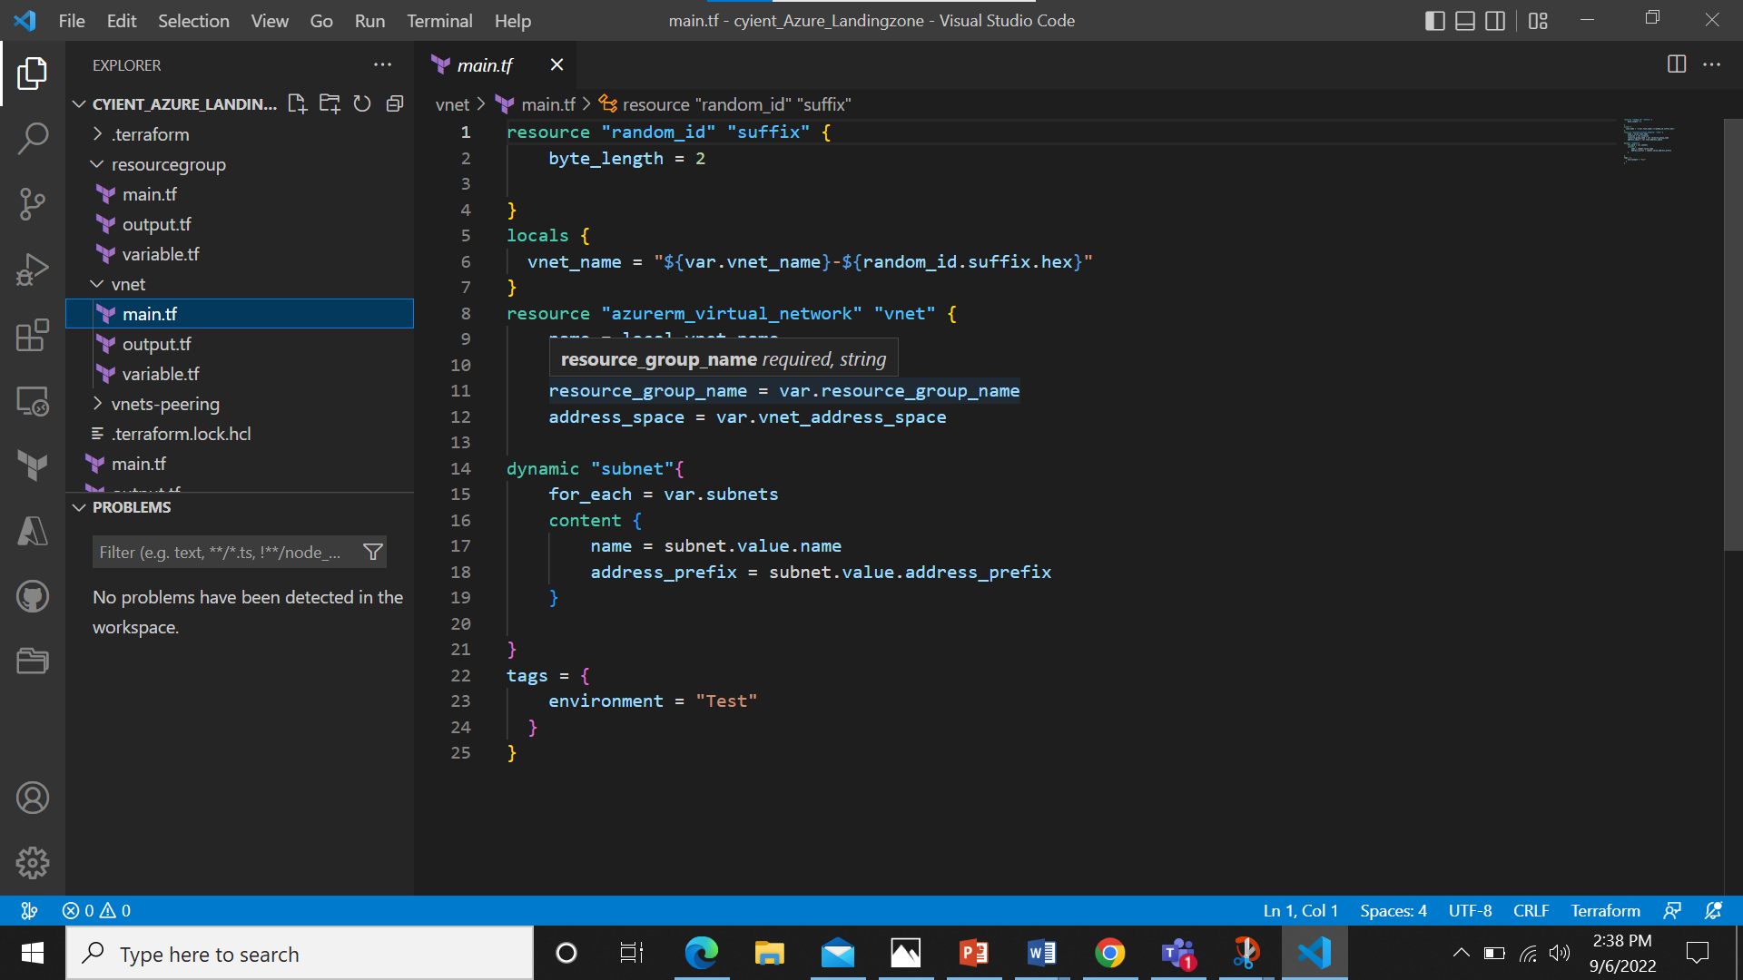

Each folder has a main.tf, variable.tf and output.tf.

The Resource group module is simple, it has only two parameters with resource group name and location.

Vnet module is designed in such a way that it can be used to create as many vnets and subnets we need to create.

**Step2**: Creation of Terraform.tfvars

To pass the desired number of vnets we need to use terraform.tfvars file in which details of the VNET’s and Subnets are provided for the deployment.

## below image is of terraform.tfvars

vnets = [

  {    vnet_name          = "Cyient_Azure_LandingZone_Automation_workload_vnet"

    vnet_address_space = ["10.0.0.0/16"]

    subnets = [

      {

        address_prefix = "10.0.1.0/24"

        name           = "Cyient_Azure_LandingZone_publicsubnet1"

      },

      {

        address_prefix = "10.0.2.0/24"

        name           = "Cyient_Azure_LandingZone_publicsubnet2"

      },

      {

        address_prefix = "10.0.3.0/24"

name           = "Cyient_Azure_LandingZone_privatesubnet1"

      },

      {

        address_prefix = "10.0.4.0/24"

        name           = "Cyient_Azure_LandingZone_privatesubnet2"

      },

      {

        address_prefix = "10.0.5.0/24"

        name           = "Cyient_Azure_LandingZone_privatesubnet3"

      },

      {

        address_prefix = "10.0.6.0/24"

        name           = "Cyient_Azure_LandingZone_privatesubnet4"

      },

    ]

  },

{

    vnet_name          = "Cyient_Azure_LandingZone_test-vnet"

    vnet_address_space = ["10.80.0.0/16"]

    subnets = [

      {

        name           = "Cyient_Azure_LandingZone_subnet1"

        address_prefix = "10.80.2.0/24"

      },

      {

        name           = "Cyient_Azure_LandingZone_subnet2"

        address_prefix = "10.80.1.0/24"

      },

    ]

  },

]

**Step3**: Deployment of Virtual Networks and Resources

Two modules need to be ran from main script, we will comment the peering modules and run the modules of resource group and vnet. Once resource group and vnet are created, we will copy the resource group name and pass it to the second file Cyient_Azure_Landingzone_bastion there we get bastion vnet ID, and the name of the bastion we have created.

module "Create_vnet" {

  source             = "./virtualnetwork"

  vnet_name          = var.root_vnet_name

  vnet_location      = var.root_location

  vnet_address_space = var.root_vnet_address_space

  vnet_subnets       = var.root_vnet_subnets

  vnet_rg_name       = var.root_rg_name

}

module "create_bastion" {

  source          = "./bastion"

  pip_name        = var.root_pip_name

  pub_ip_location = var.root_location

  pub_ip_rg_name  = var.root_rg_name

  bast_name       = var.root_bast_name

  bast_location   = var.root_location

  bast_rg_name    = var.root_rg_name

  bast_subnet_id  = module.Create_vnet.subnet_id_out[0]

}

We pass the bastion name and Id of bastion vnet to the main file Cyient_Azure_Landingzone now we do the hub and spoke peering by removing the comments in desired modules in main file.

module "create-bast-to-dev-vnetpeering" {

  source              = "./vnets-peering"

  peeringname         = "bast-to-dev"

  resource_group_name = module.Create_RG.resourcegroup_out

  vnet_name           = var.bast_vnet_name

  remote_vnet_id      = module.Create_vnet[var.vnets[0].vnet_name].vnet_id_out

}

module "create-dev-to-bast-vnetpeering" {

  source              = "./vnets-peering"

  peeringname         = "dev-to-bast"

  resource_group_name = module.Create_RG.resourcegroup_out

  vnet_name           = module.Create_vnet[var.vnets[0].vnet_name].vnet_name_out

  remote_vnet_id      = var.bast_vnet_id

}

module "create-bast-to-prod-vnetpeering" {

  source              = "./vnets-peering"

  peeringname         = "bast-to-prod"

  resource_group_name = module.Create_RG.resourcegroup_out

  vnet_name           = var.bast_vnet_name

  remote_vnet_id      = module.Create_vnet[var.vnets[1].vnet_name].vnet_id_out

}

8. Post Deployment Validation

Once you create Resource group and vnet through script You will get the output in Visual Studio terminal as resource_group_out.

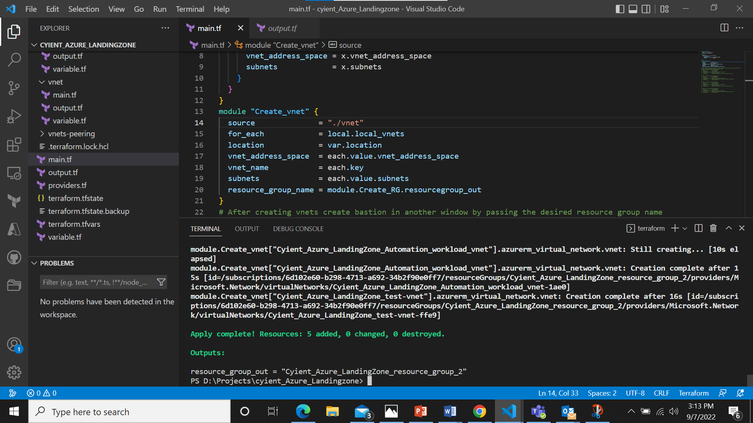

Login into portal.azure.com with required access so we can see the resource group along with vnets which was created.

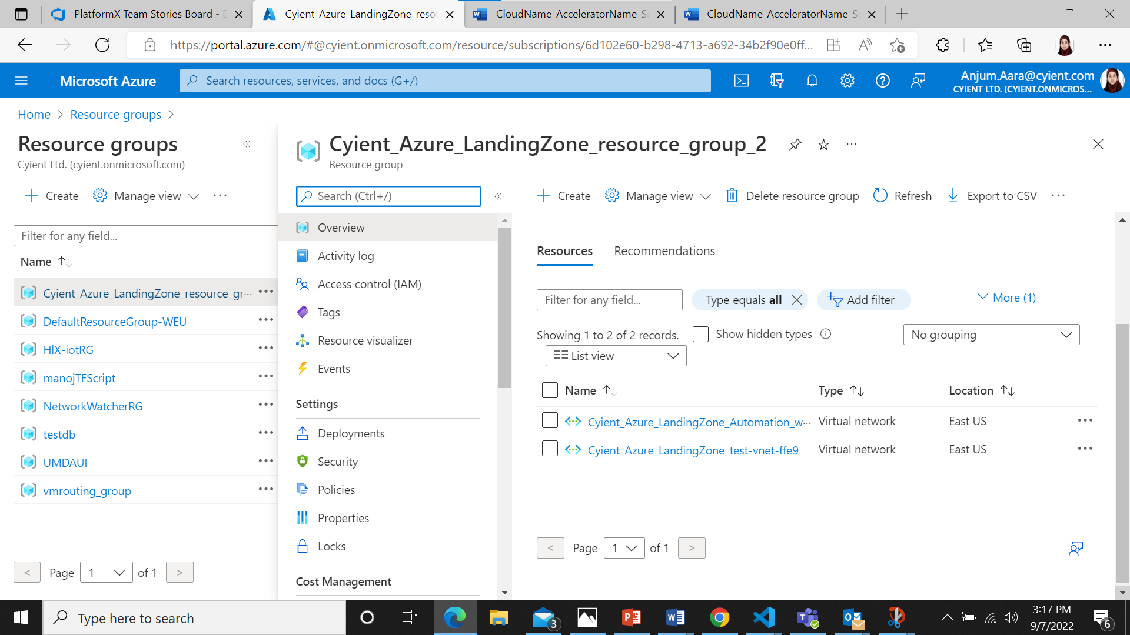

Then we can check for bastion creation. Once bastion is created we can check in Azure portal

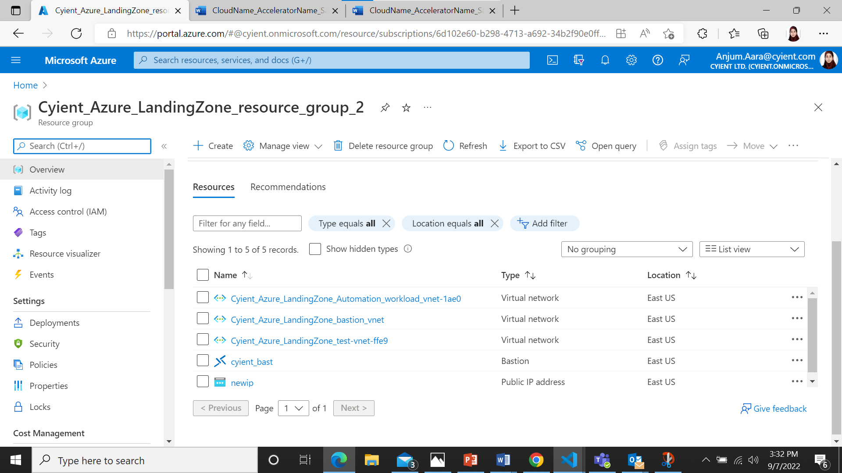

Now we have 3 vnets peered with hub and spoke model, and check for the status of the peering has to be connected.

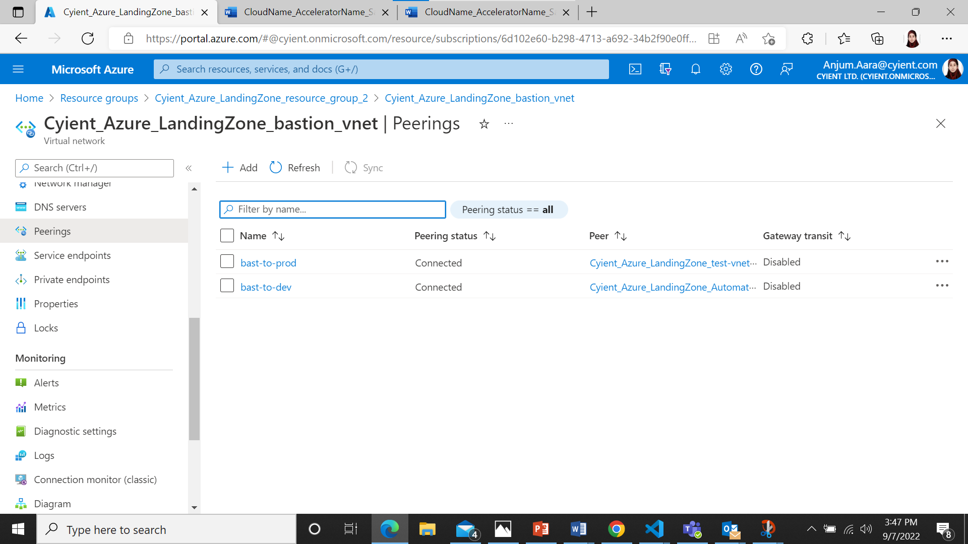

Code is stored in GitHub Repository

https://github.com/CyientCTP/LandingZone_terraform.git

Contact Person: [anjum.aara@cyient.com](mailto:anjum.aara@cyient.com)

For access to Github Repo’s get the approval from Vikashkumar.Karuna@cyient.com